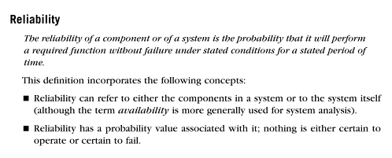
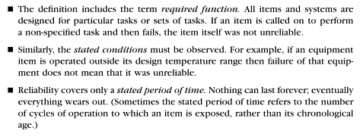
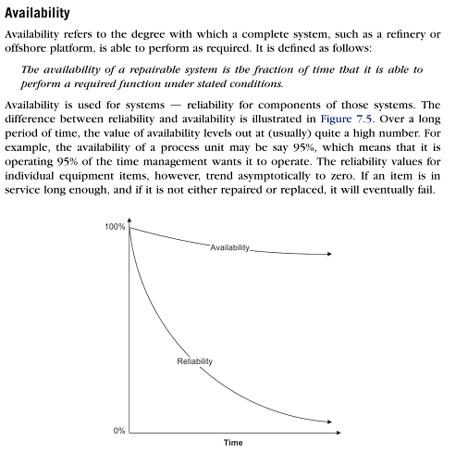
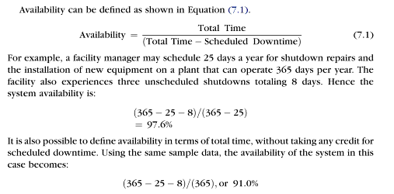

Cloud computing vs Grid computing

Cloud computing:
Cloud is basically an extension to the object-oriented programming concept of abstraction. Here cloud means the Internet. For the end users it is just getting outputs for certain inputs, the complete process that lead to the outputs is purely invisible. Computing is based on virtualized resources which are placed over multiple servers in clusters.
Also within the “cloud computing” family, are what’s known as a SPI model SaaS, PaaS and IaaS. These are the services available on the cloud and do all the heavy lifting using someone else’s infrastructure. Cloud computing eliminates the costs and complexity of buying, configuring, and managing the hardware and software needed to build and deploy applications; these applications are delivered as a service over the Internet (the cloud).

Grid computing:
Grid systems are designed for collaborative sharing of resources. It can also be thought of as distributed and large-scale cluster computing. A Grid is basically the one that uses the processing capabilities of different computing units for processing a single task. The task is broken into multiple sub-tasks, each machine on a grid is assigned a task. As when the sub-tasks are completed they are sent back to the primary machine which takes care of the all the tasks. They are combined or clubbed together as an output.

Cloud vs Grid computing: Conclusion
- Server computers are still needed to distribute the pieces of data and collect the results from participating clients on grid.
- Cloud offers more services than grid computing. In fact almost all the services on the Internet can be obtained from cloud, eg web hosting, multiple Operating systems, DB support and much more.
- Grids tends to be more loosely coupled, heterogeneous, and geographically dispersed compared to conventional cluster computing systems.
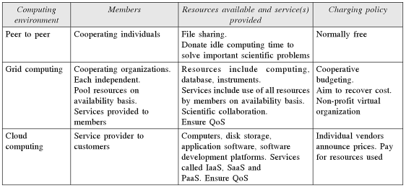
Difference between cloud computing and grid computing
• Cloud computing involves the use of services on the internet rather than local computers while grid computing involves sharing of tasks over multiple computers.
• Resources of multiple computers are shared in grid computing which greatly helps in improving the flexibility and power of the network whereas this not the case with cloud computing.
• Applications like spreadsheets, presentations, email and word processors are part of cloud computing whereas in grid computing, data storage or complex calculations are done.

Availability is the ratio of time a system or component is functional to the total time it is required or expected to function. This can be expressed as a direct proportion (for example, 9/10 or 0.9) or as a percentage (for example, 90%). It can also be expressed in terms of average downtime per week, month or year or as total downtime for a given week, month or year. Sometimes availability is expressed in qualitative terms, indicating the extent to which a system can continue to work when a significant component or set of components goes down.
Top-down Approach
1) It starts by identifying the major components of the system, decomposing them into their lower-level components and iterating until the desired level of detail is achieved.
2) It starts from the highest level component of the hierarchy and proceeds to lower levels.
3) It results in some form of stepwise refinement.
4) Starting from an abstract design, in each step the design is refined to a more concrete level, until we reach where no more refinement is needed and the design can be implemented directly.
5) It is suitable only if the specifications are clearly known.
6) It is suitable if a waterfall type of process model is being used.
Bottom-up Approach
1) It starts with designing the most basic or primitive components and proceeds to higher-level components that use these lower-level components.
2) It starts with the lowest level component of the hierarchy and proceeds through progressively higher levels.
3) It works with layers of abstraction.
4) Starting from the very bottom, operations that provide a layer of abstraction are implemented, until the stage is reached where the operations supported by the layer are those desired by the system.
5) It is suitable if a system is to be built from an existing system.
6) It is suitable if an iterative enhancement type of process is being followed.

